Curriculum Vitae (CV)

Title | Dr. | First Name | Savitri | Last Name |  | Meena
Designation |  | Assistant Professor |  |  |  |  | 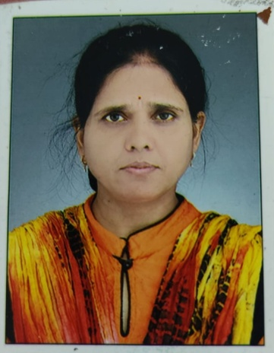
Department |  | Education
Address  (Campus) |  | Department of Education, SPM College University of Delhi
Phone Number(Campus)
Fax
Email |  | savitri@spm.du.ac.in
Education |  | Post-Doc
Subject |  | Institution |  |  | Details
Education |  | ICSSR |  |  | Post-Doc
Education |  | MLS University, Udaypur |  |  | PhD
Education |  | MLS University, Udaypur |  |  | M.Ed
Research Interests/ Specialization
Tribal Education, Social Science

Teaching Experience
5 years
Publications:
Research Papers in Journals:

Participation in International Conferences/Workshops:

Workshops: Participated in four week Faculty Induction Programme
Innovative Projects:

Awards/Recognition:

Other Responsibilities:

